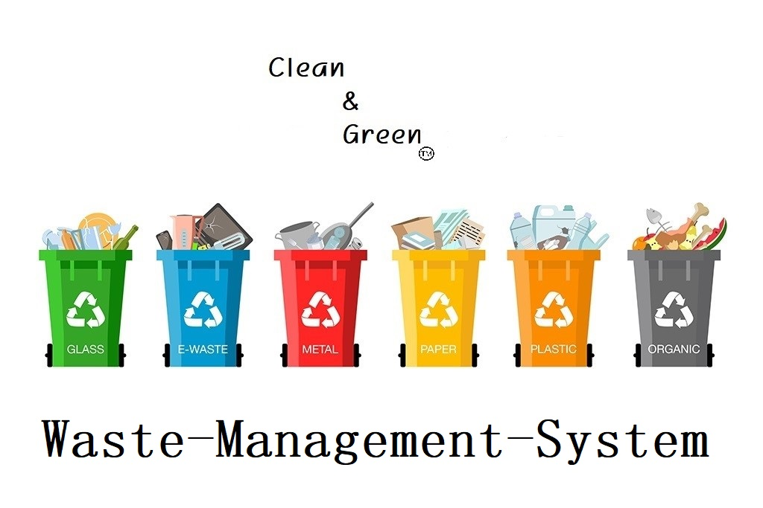

Advisor’s name: Mohammad Al Hajj

Course Name: Software Engineering

Course Code: CSCI317

Signature:

Author: Ali Hamed

ID: 1220024

Signature:

Submission date: 23/2/2022

Instructor Notes: Date of approval:

**Garbage Management System**

After a long study of waste and the crises it can pose at various levels, and after studying the capabilities and the environment in which we are located. I decided to create a program **Clean&Green**.

**Aim of this program:**

This program aims to raise awareness among people, mainly on solving the waste crisis in different ways.

What gives an additional advantage to this program is that it is a free and easy to use for the user, and it is also a program that achieves a financial return for the programmer by displaying some advertisements as an example.

**Problem Overview:**

The waste crisis is deeply rooted in Lebanon, while treatment methods are of secondary importance. The year 2015 marked an important stage in the history of the environmental explosion. In that year, a large wave of popular protests erupted in the face of official failure. At that time, the government adopted an emergency plan to treat waste, by establishing temporary central dumps in several coastal areas. But this solution was not the best solution, and even the possibility of recurring the crisis or creating another crisis because of these temporary dumps is very likely to happen.

(Change, n.d.)

**If we want to present the problems caused by waste, it will be in the following form:**

* Accumulation of waste due to the inability to pay for its disposal in an efficient and continuous manner.
* Traffic jams that cause traffic paralysis as a result of the accumulation of waste on the roads.
* Waste is a major cause and an incubator environment for harmful insects.
* Unpleasant odors.
* Closure of sewage sewers, which leads to the formation of polluted water swamps on the roads.
* Waste is a major cause of the spread of diseases, which may sometimes lead to lifelong chronic diseases and in some cases to death.

(EARTHDAY.ORG, n.d.)

**However, there are many things we can do in order to fix these problems:**

* Frequent use and reduce consumption, such as bringing old empty bags to the grocery store to put what we need instead of consuming new bags.
* Recycling and treatment of organic waste.
* Sanitary landfill that meets certain standards, while keeping these landfills under control so that no leakage and thus contamination of the soil occurs.
* Burning waste to generate electricity from the heat generated by it.
* Selling waste to recycling companies abroad.

(ACTION FOR RENEWABLES, n.d.)

**Why is this program important and how do this program contribute to addressing these problems?**

The **Clean&Green** is in addition to what I mentioned earlier, is easy to use and free, but it depends mainly on getting people to contribute directly to solving this crisis.

This program depends on several things:

* Increasing people’s awareness by explaining to them about the potential risks caused by the accumulation of waste.
* Make people do the storing process at home by explaining to them the amount of financial return that can be collected by doing this process. They will make money from nothing.
* Guiding people on how to do the sorting process correctly in order to benefit from everything and achieve a greater financial income.
* Clarify the places and ways of selling these materials after they are sorted.

Moreover, this program is not only concerned with recyclable materials, but on the contrary, it also explains how to deal with organic materials and benefit from them.

# **Deliverables and Success Criteria – How to validate the success?**

In order to validate the success of this project, consider the following:

* Show different ways of recycling process in hopes of widening our user base to the furthest extend possible.
* Continuously update the locations and prices of the stored items.
* Put some videos that will help in the process of explaining the complex things.
* Establishing a store within this system, where the user can sell materials from his home, and companies will take care of the transportation process.
* Establishing an alert system regarding the process of creating fertilizers during the process of recycling organic materials aims to alert the user when the process is finished.
* Allow companies to post some advertisements for their services that goes with ours.

**System Users – Who can use this project?**

* Anyone
* Small companies that want to achieve greater profit.
* Large companies and municipalities.

**The Plan – What are the phases of the project?**

* General analysis and requirements gathering.
* Writing information that aims to increase people’s awareness and scientific sources for this information and adding other scientific sources.
* Creating the Product Design.
* Creating the database system.
* Generating and connect the alarm system with database.
* Establishment of the store and the mechanism of communication.
* Create a space for people to communicate with each other and to present what they do and find useful.
* link the program with database.
* Testing and solving the problems.
* Deployment of the Product and Maintenance and Operations.

**Time Plan:**

The suggested timetable of the plan is as follows. (One year in total)

|  |  |
| --- | --- |
| Starting date | 1 May 2022 |
| Ending date | 1 May 2023 |

|  |  |  |  |
| --- | --- | --- | --- |
| Activity | Start date | End date | Budget |
| 1 | 1 May 2022 | 1 June 2022 | 450$-600$ |
| 2 | 1 May 2022 | 1 June 2022 | 100$ |
| 3 | 2 June 2022 | 1 Aug 2022 | 650$-850$ |
| 4 | 1 Aug 2022 | 1 Nov 2022 | 200$-250$ |
| 5 | 1 Aug 2022 | 1 Sep 2022 | 300$-400$ |
| 6 | 1 Nov 2022 | 1 Jan 2022 | 250$-400$ |
| 7 | 1 Jan 2022 | 1 Fab 2022 | 450$-600$ |
| 8 | 1 Fab 2022 | 1 Mar 2022 | 100$ |
| 9 | 1 Mar 2022 | 1 Apr 2022 | 650$-850$ |
| 10 | 1 Apr 2022 | 1 May 2022 | 200$-250$ |

**Resources – What are the software and hardware?**

The software required for this system is the main website and its corresponding database. No associated hardware is needed.

**Conclusion**

All in all, Clean&Green is the ideal program to solve this crisis, which is constantly recurring in Lebanon, and with the increase in economic problems and increase in the population, this program is the correct way to solve the crisis.

# References

*ACTION FOR RENEWABLES*. (n.d.). Retrieved from https://www.actionforrenewables.org/how-to-counter-waste-disposal-challenges/

Change, C. (n.d.). Retrieved from https://nouhadawwad.wordpress.com/2018/02/10/waste-crisis-in-lebanon/

*EARTHDAY.ORG*. (n.d.). Retrieved from https://www.earthday.org/how-our-trash-impacts-the-environment/